ACADEMIA INTERNACIONAL DE DAVID


TECHNOLOGY
SUMMATIVE ACTIVITY # 1

NAME: __________________________DATE: _______________________ 3^{rd Grade}: A B C
TEACHER: EDGAR PITTY
Name and date: 1pt |  | Follow Instructions: 2pt
Order: 1pt |  | Correct use of tools: 1pt
CONTENT: 25 pts |  | TOTAL: 30pts

Part I: Paint the following images with the correct color assigned. 2pts each, 20 pts total
Cable | Task | Motor | Robot | Battery | Pieces | Instruction | Controller | Sensor | Wheel

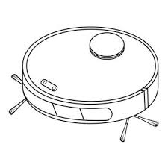
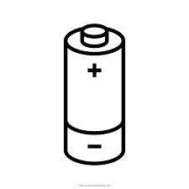
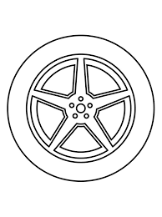
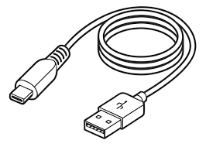

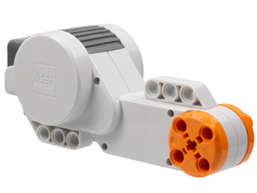
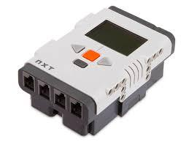
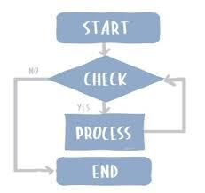

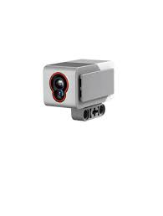


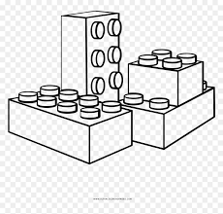

Part II: Match the correct image to its corresponding name using a dashed or straight line with the color on the right. 1 pts each, 5pts total.


Controller



Sensor



Robot
Task
Motor

